Link State Routing

*Java Implementation of Link State Routing between routers involving a controller and an End User*



This documentation includes an in-depth description of the Link State Routing, the code implementation, strength and weaknesses of my implementation and an analysis of my program using screenshots.

Sharon Olorunniwo - 16323766

15/12/2017

# Link State Routing

*Java Implementation of Link State Routing between routers involving a controller and an End User*

## Table of contents

1. What Routing?
2. Link State Routing
3. Code Implementation and Analysis
4. Alternative: Distance Vector Routing
5. References and Reflection



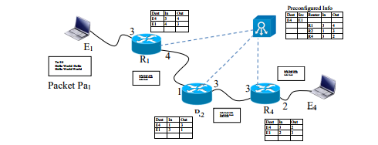

*What is Routing?*

Routing is the process of selecting a path for traffic in a network, or between or across multiple networks. Routing is performed for many types of networks, including circuit-switched networks, such as the public switched telephone network (PSTN), computer networks, such as the Internet.

In packet switching networks, routing is the higher-level decision making that directs network packets from their source toward their destination through network nodes by specific packet forwarding mechanisms. Packet forwarding is the transit of logically addressed network packets from one network interface to another. Computers also forward packets and perform routing, although they have no specially optimized hardware for the task. The routing process usually directs forwarding using routing tables, which maintain a record of the routes to various network destinations. Thus, constructing routing tables, which are held in the router's memory, is very important for efficient routing. Most routing algorithms use only one network path at a time. Multipath routing techniques enable the use of multiple alternative paths.

A router is a networking device that forwards data packets between computer networks. Routers perform the traffic directing functions on the Internet. A data packet is typically forwarded from one router to another router through the networks that constitute an internetwork until it reaches its destination node.

A router is connected to two or more data lines from different networks. When a data packet comes in on one of the lines, the router reads the network address information in the packet to determine the ultimate destination. Then, using information in its routing table or routing policy, it directs the packet to the next network on its journey.

*What is Link State Routing?*

Link-state routing protocols are one of the two main classes of routing protocols used in packet switching networks for computer communications, the other being distance-vector routing protocols. Examples of link-state routing protocols include Open Shortest Path First (OSPF) and intermediate system to intermediate system (IS-IS).

The basic concept of link-state routing is that every node constructs a ***map*** of the connectivity to the network, in the form of a [graph](https://en.wikipedia.org/wiki/Graph_theory), showing which nodes are connected to which other nodes. Each node then independently calculates the next best logical ***path*** from it to every possible destination in the network. Each collection of best paths will then form each node's [routing table](https://en.wikipedia.org/wiki/Routing_table).

This contrasts with [distance-vector](https://en.wikipedia.org/wiki/Distance-vector_routing_protocol) routing protocols, which work by having each node share its routing table with its neighbours. In a link-state protocol the only information passed between nodes is ***connectivity related*.** Link-state algorithms are sometimes characterized informally as each router, "telling the world about its neighbours."

Each node runs an algorithm over the map to determine the shortest path from itself to every other node in the network; generally, Dijkstra's algorithm is used. This is based around a link cost across each path which includes available bandwidth among other things.

A node maintains two data structures: a tree containing nodes which are "done", and a list of candidates. The algorithm starts with both structures empty; it then adds to the first one the node itself.

Link State Routing Protocols converge more quickly, and they are less prone to Routing Loops than Distance Vector Routing Protocols. On the other hand, Link State Routing Protocols require more CPU power and memory than Distance Vector Routing Protocol algorithms. Link State Protocols use a hierarchical structure that limits the distance that a Link-State Advertisement (LSA) need to travel. Link State Protocols use multicasts to share the routing information. Only the routers which run Link State protocol only process the updates. Link State routers send updates only when there is a change in the state of the network (incremental updates).

*Code Implementation and Analysis?*

My program consists of the following components. They engage in the routing event

● Controller

● Routers

● End​ ​Users

When the​ ​controller​ ​is​ ​established​ ​on​ ​a​ ​port​ ​on​ ​the​ ​network​ ​address​ ​(​localhost​)​ ​it​ ​begins​ ​by  designing​ ​a​ ​routing​ ​table​ ​for​ ​the​ ​network.​ ​This​ ​is​ ​achieved​ ​using​ ​a​ ​nested​ ​​HashMap​​ ​data  structure​ .

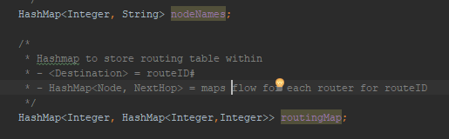

Each​ ​​router​​ ​in​ ​the​ ​network​ ​is​ given a port number​​. ​ ​When​ ​a router​ ​is​ ​created​ ​it​ ​is​ ​initialised​ ​with​ ​an​ ​empty​ ​routing​ ​table​ ​containing​ ​all​ ​of​ ​the​ ​end​ ​users in​ ​the​ ​network. ​ ​

The ​​RouteKey​​ ​​class​ models​ ​the​ ​routing​ ​table. ​ ​Each​ ​node​ ​within​ ​the​ ​ routing​ ​table ​has​ ​a corresponding​ ​value​​​ ​and​ ​within​ ​the​ ​​RouteKey​ ​​is​ ​the​ ​address​ ​of the​ ​​NextHop​ ​​for​ ​that​ ​ node​ ​and​ ​also​ ​the​ distance​ ​in​ ​hops​ ​to​ ​the node.

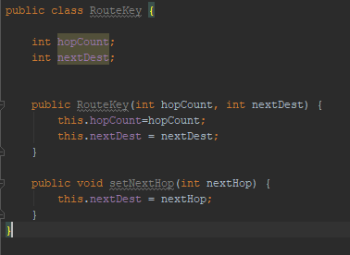

Once​ ​the​ ​controller​ ​and​ ​all​ ​routers​ ​in​ ​the​ ​network​ ​have​ ​been​ ​created​ ​and​ ​initialised​ ​the​ ​​end​ ​users​ ​​are ​established.​ ​When​ ​an​ ​end​ ​user​ ​is​ ​created​ ​it​ ​knows​ ​the port​ ​of​ ​the​ ​router​ ​that​ ​it​ ​is​ ​connected​ ​to.​ ​​They​ ​will​ ​then​ ​be  prompted​ ​to​ ​input​ ​the​ ​text​ ​to​ ​be​ ​sent​ ​within​ ​the​ ​packet​ ​to​ ​the​ ​defined​ ​end​ ​user.

This​ ​packet​ ​is​ ​then​ ​sent​ ​to​ ​the​ ​connected​ ​router​ ​for​ ​the​ ​given​ ​end​ ​user​ ​node​ ​using Datagram​ ​Packets​ ​and​ ​Sockets.​ ​When​ ​a​ ​packet​ ​is​ ​received​ ​at​ ​a​ ​router​ ​it​ ​first​ ​gets ​the destination​​ ​address​ ​from​ ​the​ ​packet,​ ​this​ ​is​ ​then​ ​ ​referenced​ ​with​ ​the​ ​RoutingTable​​ ​for​ ​the​ ​router​ ​to​ ​check​ ​if​ ​it​ ​has​ ​knowledge​ ​of​ ​how​ ​to​ ​get​ ​to​ ​ destination​​.​ ​

Then,​ ​each​ ​router​ ​and​ ​end​ ​user​ ​node​ ​in​ ​the​ ​network​ ​is​ ​created​ ​at​ ​its​ ​respective​ ​port​ ​on​ ​the  network​ ​address​ ​(​localhost​).​ ​When​ ​a​ ​node​ ​is​ ​created​ ​it​ ​sends​ ​a​ ​​Controller​ ​Packet​ ​​to  the​ ​controller​ ​which​ ​informs​ ​it​ ​of​ ​all​ ​the​ ​local​ ​connections​ ​for​ ​the​ ​node.​ ​The​ ​controller  processes​ ​the​ packet​ ​and​ ​starts​ ​to​ ​build​ ​a​ ​network​ ​map​ ​for​ ​all​ ​connections.

Once​ ​the​ ​controller​ ​has​ ​received​ ​an​ ​information​ ​packet​ ​from​ ​each​ ​node​ ​in​ ​the​ ​network​ ​it begins​ ​discovering​ ​the​ ​quickest​ ​route​ ​between​ ​each​ ​end​ ​user​ ​node​ ​in​ ​the​ ​network. ​ ​This​ ​is done​ ​by​ ​implementing​ ​a​ ​version​ ​of​ ​​Link​ ​State​ ​Routing​​ ​using​ Dijkstra’s algorithm​ ​without​ ​having​ between​ ​each​ ​node.

When​ ​the​ ​controller​ ​has​ ​finished​ ​this​ ​process​ ​it​ ​then​ ​has​ ​full​ ​knowledge​ ​of​ ​the​ ​best​ ​routes between​ ​all​ ​end​ ​users​ ​in​ ​the​ ​network​ ​stored​ ​in​ ​a​ ​​Routing​ ​Table​.​ ​Once​ ​the​ ​​Routing​ ​Table​​ ​is  fully​ ​populated​ ​the​ ​controller​ ​informs​ ​each​ ​affected​ ​node​ ​of​ ​their​ ​​NextHop​​ ​address​ ​for  when​ ​a​ ​packet​ ​is​ ​being​ ​attempted​ ​to​ ​be​ ​sent​ ​to​ ​an​ ​end​ ​user.

### ​ Code Snippets of the Routing Process

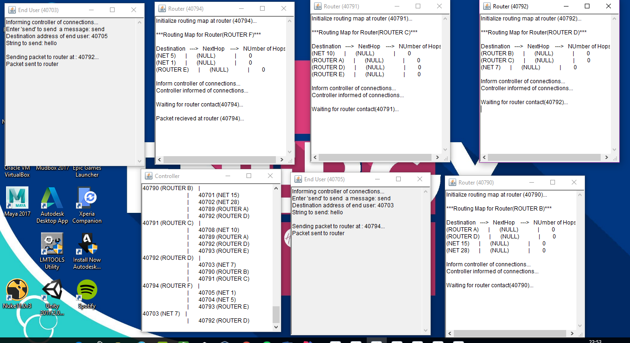

​

### References and Reflection

So, the whole assignment was a very interesting journey. For this assignment I decided to implement it in Java as I had initially found this assignment quite challenging, so it would be easier to get help from my classmates as the majority were also doing it in java. I also did not have the luxury of time to continue exploring the Python, regardless it was definitely a learning experience for me once I understood the purpose of the assignment it was a lot easier to continue. Completing the assignment has given me a better understanding of how routers work. I attempted this assignment to the best of my ability although the outcome may not have been what I wanted I did learn.

Here are the links to sites I referenced during this Assignment

* <https://en.wikipedia.org/wiki/Routing>
* <https://en.wikipedia.org/wiki/Router_(computing)>
* <http://www.wavelink.com.au/information/router-defined.php>
* <https://en.wikipedia.org/wiki/Link-state_routing_protocol>
* <http://www.omnisecu.com/cisco-certified-network-associate-ccna/introduction-to-link-state-routing-protocols.php>